|  |  |
| --- | --- |
|  | OPTIMIZATION TECHNIQUE |
| Eswaran |  |
| 5/11/2017 | OT – Group Assignment |
|  | **Group 12**  Pavan  Dinesh  Abhishek  Eswaran  Prashanth  Santhosh |

Contents

Question 1 2

Formulation 2

Decision Variables : 2

Objective Function: 3

Constraints 3

Results 3

Question 2 4

Formulation 5

Decision Variables: 5

Question 3 6

Formulation 6

Decision Variables: 6

Objective 6

Constraints 7

Question 4 7

Answer 8

Question 5 9

Formulation – 5a 11

Decision Variables: 11

Objective Function | Minimize Z 11

Constraints 12

Answer 12

Formulation – 5b 13

Decision Variable 13

Objective Function – Minimize Z – Minimize Cost 13

Constraints 13

Answer 14

Solved Excel 14

OPTIMIZATION TECHNIQUE

OT – Group Assignment

# Question 1

1. The U-save company is planning its operations for the next year. The company is considering investing in four types of securities. The company has $1 million available for investment. The expected annual return and the “risk index” of each security are as follows:

Expected return Risk index

(%)

Long-term Bonds 15% 3

Medium-term Bonds 12% 4

Government Bonds 9% 7

Short-term Bonds 10% 9

The company wants to maximize the expected return from its bond investments, subject to the following restrictions:

* The average risk index of the portfolio should not exceed 6
* At most 45% of the total amount invested can be invested in any single bond
* The expected return of the Government bond portfolio should be at least 1.2 times the return of the Long term and medium term bond portfolio.

Formulate the problem as a LP problem. Define the decision variables carefully. Use any software at your disposal to obtain an optimal solution.

## Formulation

### Decision Variables :

Amount to be invested in each of Bond. Can be better explained with,

X1 = Amount Invested in Long-Term Bonds

X2 = Amount Invested in Medium-Term Bonds

X3 = Amount Invested in Government Bonds

X4 = Amount Invested in Short Term Bonds

### Objective Function:

There are two factors impacting our Objective. Return of Investment and Risk Index. Our objective is to Increase the Returns of Investment . Maximizing Z.

Where,

Ret***j*** = Return from various Bonds

Risk***j*** = Risk Index of Various bonds.

$$Z=\sum_{i=1}^{4}{\left(Xi×Reti\right)-(Xi×Riski)}$$

Maximize – Z

### Constraints

|  |  |  |
| --- | --- | --- |
| Available Fund | = | 1000000 |
| Average Risk Portfolio | <= | 6% |
| Long Term | <= | 450000 |
| Medium Term | <= | 450000 |
| Government bonds | <= | 450000 |
| Short Term | <= | 450000 |
| Govt Bond Expected Return Rate | >= | 1.2 X (Long Term and Mid Term) |

### Results

|  |  |
| --- | --- |
| **Objective: (Maximize Returns) - Z** | **19250** |

|  |  |  |  |
| --- | --- | --- | --- |
| **X1** | **X2** | **X3** | **X4** |
| 0 | 93750 | 450000 | 275000 |

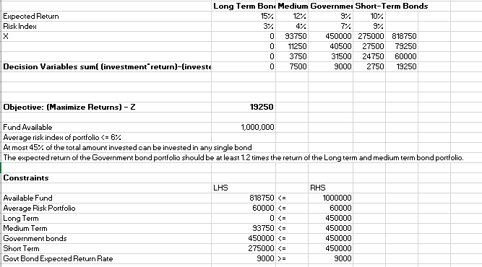

# Question 2

1. The Crazy Nut company wishes to market two special nut mixes during the holiday season. Every pound of mix 1 contains 0.5 pound of peanuts and 0.5 pound of cashews; Every pound of Mix 2 contains 0.6 pound of peanuts, 0.25 pound of cashews, and 0.15 pound of almonds. Mix 1 sells for $1.49 per pound; Mix 2 sells for $1.69 per pound. The data pertinent to the raw ingredients appear in the table

Ingredient Amount available Cost per lb.

(lb) ($)

Peanuts 30,000 $0.35

Cashews 12,000 $0.50

Almonds 9,000 $0.60

Assuming that Crazy can sell all cans of either mix that it produces, formulate an LP model to determine how much of mixes 1 and 2 to produce. Use any software at your disposal to obtain an optimal solution.

## Formulation

### Decision Variables:

X1 = Number of bags of Mix 1

X2 = Number of Bags of Mix 2

**Objective Function:**

Maximize Z = 1.49X1 + 1.69X2

**Constraints**

0.5X1 + 0.60X2 ≤ 30000 (Peanuts)

0.5X1 + 0.25X2 ≤ 12000 (Cashews)

0.15X2 ≤ 9000 (Almonds)

where X1, X2 ≥ 0

**Solution:**

**X1 = 0 {**0 Bags of Mix1}

**X2 = 48000 {** 48000 bags of Mix 2 }

**Z = 81120**

**Profit :**

|  |  |  |  |
| --- | --- | --- | --- |
| **Profit** |  |  |  |
| Peanuts | 28800 | 0.6 | 17280 |
| Cashews | 12000 | 0.25 | 3000 |
| Almonds | 7200 | 0.15 | 1080 |
|  |  |  | 21360 |
|  | **Profit** |  | **59760** |

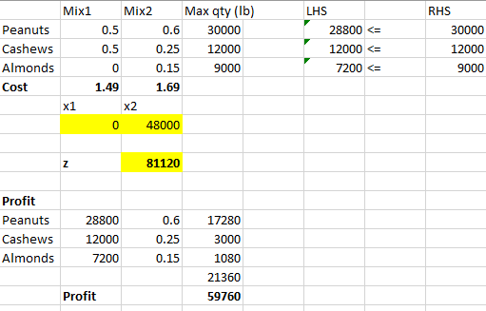

# Question 3

You have decided to enter the candy business. You are considering producing two types of candies: Slugger Candy and Easy Out Candy, both of which consist solely of sugar, nuts, and chocolate. At present, you have in stock 100 oz of sugar, 20 oz of nuts, and 30 oz of chocolate. The mixture used to make Easy Out candy must contain at least 20% nuts. The mixture used to make Slugger Candy must contain at least 10% nuts and 10% chocolate. Each ounce of Easy Out Candy can be sold for 25 cents, and each ounce of Slugger Candy can be sold for 20 cents. Formulate an LP that will enable you to maximize your revenue from candy sales. Use any software at your disposal to obtain an optimal solution.

## Formulation

### Decision Variables:

Oz of Easy Out Candy produced = X1 + X2 + X3 ( sugar, nuts & Chocolate)

Ozof Slugger Candy produced = Y1 + Y2 + Y3 ( sugar, nuts & Chocolate)

### Objective

Maximize the Revenue through Sales

Max Z = 25*(X1 + X2 + X3)+20*( Y1 + Y2 + Y3)

### Constraints

20% of Nuts in Easy Out Candy : 0.8 X2 – 0.2 X1 – 0.2 X3 ≥ 0

10% of Nuts in Slugger Candy : - 0.1Y1+ 0.9Y2- 0.1Y3 ≥ 0

10% of chocolate in Slugger Candy : - 0.1Y1- 0.1Y2+ 0.9Y3≥ 0

Sugar : X1+Y1 ≤ 100

Nuts : X2+Y2 ≤ 20

Chocolate : X3+Y3 ≤ 30

**Solution**

|  |  |
| --- | --- |
| Easy Out Chocolates (In Ounces) | **50** |
| Slugger Candy (In Ounces) | **100** |
| Total profit | **$3250** |

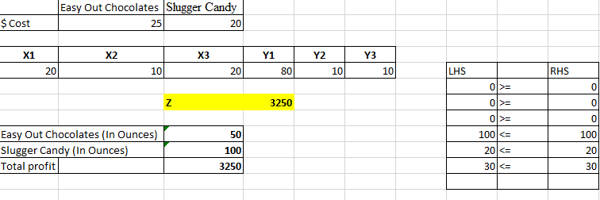

# Question 4

Consider the staffing problem faced by the Great Lakes Bus Company that requires the following number of drivers on each day.

Day Mon Tue Wed Thu Fri Sat Sun

Number needed 19 16 14 16 19 14 10

Each driver works for 5-consecutive days in a week and then receives two days off. The company assumes that if more than required number of drivers are scheduled to work on any given day, then the extra drivers will be given a paid day off. The company solves the following linear program to determine the optimal staffing plan

MIN Z = X1 + X2 + X3 + X4 + X5 + X6 + X7

Subject to

X1 + +X4 + X5 + X6 + X7 > 19

X1 + X2 + X5 + X6 + X7 > 16

X1 + X2 + X3 + X6 + X7 > 14

X1 + X2 + X3 + X4 + X7 > 16

X1 + X2 + X3 + X4 + X5 > 19

+ X2 + X3 + X4 + X5 + X6 > 14

X3 + X4 + X5 + X6 + X7 > 10

X1, X2, X3, X4, X5, X6, X7 > 0

Using a linear programming software, the optimal solution was found to be:

X1 = 8; X2 = 3; X3 = 0; X4 = 5; X5 = 3; X6 = 3; X7 = 0

## Answer

Answer the following questions based on the above information.

What is the definition of the decision variables in the linear program used by the company?

Ans: Number of Drivers in particular batch stared to work on each day in a week viz.,

X1 starts on Monday,

X2 on Tuesday

X3 Starts on Wednesday

X4 Starts on Thursday

X5 Starts on Friday

X6 Starts on Saturday

X7 Starts on Sunday.

Describe the objective function (in words) that the company uses in the linear program

Ans: Total minimum number of drivers required on for everyday in week.

Determine the optimal value of the objective function

Ans:22

Based on the optimal solution, how many drivers will be scheduled to work on Monday?

Ans:19

Based on the optimal solution, how many drivers will be scheduled to work on Tuesday?

Ans:17

Suppose the drivers were paid $ 50 per weekday and $ 80 for Saturday or Sunday, What is the total money paid to the drivers if the optimal plan determined above was implemented.

Ans:$6250 (calculation attached in worksheet)



# Question 5

Company XYZ is facing network coordination issues and is contemplating to move from multi-sourcing to single sourcing. Currently, they have five suppliers shipping parts to three of their manufacturing plants.

|  |  |  |  |  |
| --- | --- | --- | --- | --- |
| Supplier data | |  | |  |
| **Supplier** | | **Annual Fixed Cost in Coordinating with Supplier ($)** | | **Annual Capacity of Supplier (units)** |
| A | | **20,000** | | **5000** |
| B | | **25,000** | | **3000** |
| C | | **20,000** | | **7000** |
| D | | **18,000** | | **5000** |
| E | | **27,000** | | **6000** |
| Plant data | |  | |  |
|  |  | |
| **Plant** | **Annual Demand at Plant** | |
| X | **5000** | |
| Y | **3000** | |
| Z | **2000** | |

Production and Transportation Cost Data:

|  |  |  |  |
| --- | --- | --- | --- |
|  |  |  |  |
| **Supplier/ Plant** | X | Y | Z |
| A | **$5** | **4** | **5** |
| B | **4** | **6** | **5** |
| C | **5** | **4** | **12** |
| D | **8** | **7** | **3** |
| E | **10** | **7** | **3** |
|  |  |  |  |

5a.The company wants to reduce their supply base for better coordination by single sourcing, i.e., a single supplier sources each plant. Develop a model that would identify an optimal solution for the company.

5b. Formulate problem 3a as a multiple supplier sourcing model, i.e., you are removing the restriction that a plant can only be sourced from a single supplier.

## Formulation – 5a

### Decision Variables:

Xij = Select 1 if supplier i is chosen or 0 otherwise

Yi = Select 1 if supplier i is chosen or 0 otherwise

### Objective Function | Minimize Z

Min ( 5 (5000) X11 +

6 (3000) x12 +

7 (2000) x13 +

2 (5000) X21 +

3 (3000) X22 +

4 (2000) X23 +

5 (5000) X31 +

4 (3000) X32 +

12 (2000) X33 +

8 (5000) X41 +

7 (3000) X42 +

3 (2000) X43 +

10 (5000) X51 +

7 (3000) X52 +

3 (2000) X53 +

20000 Y1 +

25000 Y2 +

20000 Y3 +

18000 Y4 +

27000 Y5)

### Constraints

X11 + X21 + X31 + X41 + X51 = 1

X12 + X22 + X32 + X42 + X52= 1

X13 + X23 + X33 + X43 + X53= 1

(5000) X11 + (3000) X12 + (2000) X13 <= 30000 Y1

(5000) X21 + (3000) X22 + (2000) X23 <= 30000 Y2

(5000) X31 + (3000) X32 + (2000) X33 <= 7000 Y3

(5000) X41 + (3000) X42 + (2000) X43 <= 5000 Y4

(5000) X51 + (3000) X52 + (2000) X53 <= 6000 Y5

Xij= {0,1}

Yi = {0,1}

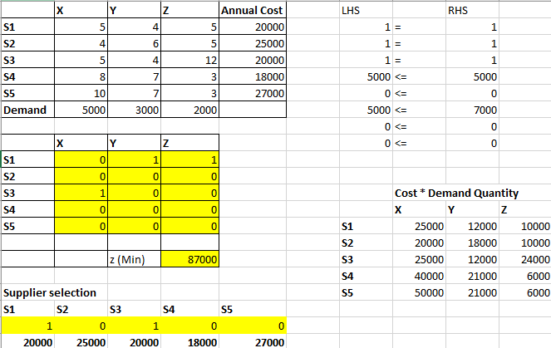

## Answer

Supplier S3 will meet X Demand

Supplier S1 will meet both Y and Z demand

With minimum cost of $87000

## Formulation – 5b

### Decision Variable

Xij - quantity to transport for supplier i to customer zone j

Yi = 1 if supplier i is chosen or 0 otherwise

### Objective Function – Minimize Z – Minimize Cost

Min (5 X11 + 4 x12 + 5 x 13 + 4 X21 + 6 X22 + 5 X23 + 5 X31 + 4 X32 + 12 X33 + 8 X41 + 7 X42 + 3 X43 + 10 X51 + 7 X52 + 3 X53 + 20000 Y1 + 25000 Y2 + 20000 Y3 + 18000 Y4 + 27000 Y5)

### Constraints

X11 + X21+X31+X41+X51 = 5000

X12 + X22+X32+X42+X52 = 3000

X13 + X23+X33+X43+X53 = 2000

X11 + X12 + X13 <= 5000 Y1

X21 + X22 + X23 <= 3000 Y2

X31 + X32 + X33 <= 7000 Y3

X41 + X42 + X43 <= 5000 Y4

X51 + X52 + X53 <= 6000 Y5

Xij >= 0

Yi = {0,1}

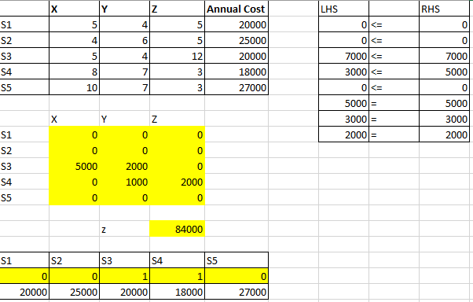

## Answer

Supplier S3 will meet the demand of Plant X and Y with 5000 and 2000 units respectively

Supplier S4 will meet the demand of Plan Y and Z with 1000 and 2000 units respectively

With the minimum cost of $84000

# Solved Excel

